Command: LIMITS

Reset Model space limits:

Specify lower left corner or [ON/OFF] <0.0000,0.0000>: -85,0

Specify upper right corner <420.0000,297.0000>: 80,35

Command: SNAP

Specify snap spacing or [ON/OFF/Aspect/Legacy/Style/Type] <10.0000>: 5

Command: GRID

Specify grid spacing(X) or [ON/OFF/Snap/Major/aDaptive/Limits/Follow/Aspect] <10.0000>: S

Command: ZOOM

Specify corner of window, enter a scale factor (nX or nXP), or

[All/Center/Dynamic/Extents/Previous/Scale/Window/Object] <real time>: A

Regenerating model.

Command: PLINE

Specify start point: -85,10

Current line-width is 0.0000

Specify next point or [Arc/Halfwidth/Length/Undo/Width]: -85,10

Specify next point or [Arc/Close/Halfwidth/Length/Undo/Width]: U

Specify next point or [Arc/Halfwidth/Length/Undo/Width]: -15,10

Specify next point or [Arc/Close/Halfwidth/Length/Undo/Width]: -10,5

Specify next point or [Arc/Close/Halfwidth/Length/Undo/Width]: 80,5

Specify next point or [Arc/Close/Halfwidth/Length/Undo/Width]: 80,10

Specify next point or [Arc/Close/Halfwidth/Length/Undo/Width]: 65,20

Specify next point or [Arc/Close/Halfwidth/Length/Undo/Width]: 60,20

Specify next point or [Arc/Close/Halfwidth/Length/Undo/Width]: 60,15

Specify next point or [Arc/Close/Halfwidth/Length/Undo/Width]: 45,20

Specify next point or [Arc/Close/Halfwidth/Length/Undo/Width]: 40,20

Specify next point or [Arc/Close/Halfwidth/Length/Undo/Width]: 40,15

Specify next point or [Arc/Close/Halfwidth/Length/Undo/Width]: 25,20

Specify next point or [Arc/Close/Halfwidth/Length/Undo/Width]: 20,20

Specify next point or [Arc/Close/Halfwidth/Length/Undo/Width]: 20,15

Specify next point or [Arc/Close/Halfwidth/Length/Undo/Width]: 5,15

Specify next point or [Arc/Close/Halfwidth/Length/Undo/Width]: 0,20

Specify next point or [Arc/Close/Halfwidth/Length/Undo/Width]: 0,30

Specify next point or [Arc/Close/Halfwidth/Length/Undo/Width]: -5,35

Specify next point or [Arc/Close/Halfwidth/Length/Undo/Width]: -15,35

Specify next point or [Arc/Close/Halfwidth/Length/Undo/Width]: -20,30

Specify next point or [Arc/Close/Halfwidth/Length/Undo/Width]: -20,20

Specify next point or [Arc/Close/Halfwidth/Length/Undo/Width]: -80,20

Specify next point or [Arc/Close/Halfwidth/Length/Undo/Width]: -85,15

Specify next point or [Arc/Close/Halfwidth/Length/Undo/Width]: -85,10

Specify next point or [Arc/Close/Halfwidth/Length/Undo/Width]: CLOSE

Command:

Command: _LINETYPE

Command:

Command: _line

Specify first point:

Specify next point or [Undo]:

Specify next point or [Undo]: *Cancel*

Command: REGION

Select objects: Specify opposite corner: 1 found

Select objects:

1 loop extracted.

1 Region created.

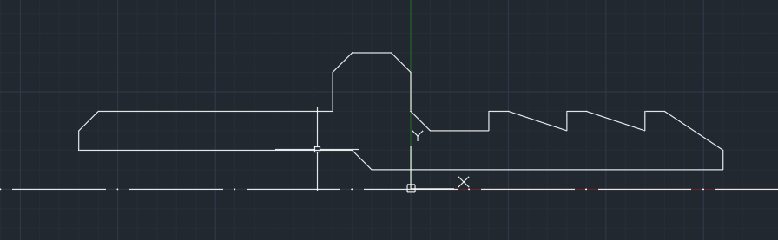

Command: REVOLVE

Current wire frame density: ISOLINES=4, Closed profiles creation mode = Solid

Select objects to revolve or [MOde]: 1 found

Select objects to revolve or [MOde]:

Specify axis start point or define axis by [Object/X/Y/Z] <Object>: X

Specify angle of revolution or [STart angle/Reverse/EXpression] <360>:

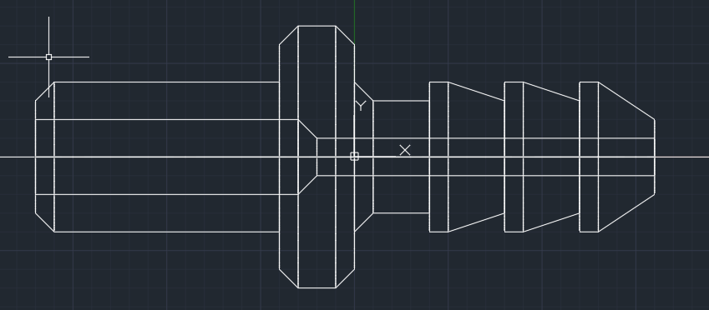

ROTATE3D

Current positive angle: ANGDIR=counterclockwise ANGBASE=0

Select objects: 1 found

Select objects:

Specify first point on axis or define axis by

[Object/Last/View/Xaxis/Yaxis/Zaxis/2points]: Y

Specify a point on the Y axis <0,0,0>:

Specify rotation angle or [Reference]: 90

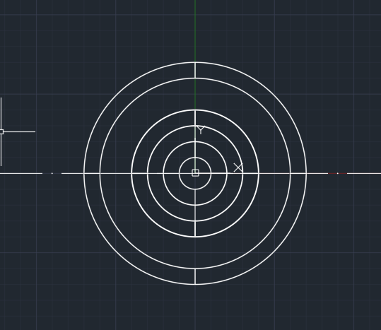

Command: POLYGON

Enter number of sides <4>: 6

Specify center of polygon or [Edge]: 0,0

Enter an option [Inscribed in circle/Circumscribed about circle] <I>: I

Specify radius of circle: 35

Command: EXTRUDE

Current wire frame density: ISOLINES=4, Closed profiles creation mode = Solid

Select objects to extrude or [MOde]: 1 found

Select objects to extrude or [MOde]:

Specify height of extrusion or [Direction/Path/Taper angle/Expression] <200.0000>: 200

Command: MOVE

Select objects: 1 found

Select objects:

Specify base point or [Displacement] <Displacement>: D

Specify displacement <0.0000, 0.0000, 0.0000>: 0,0,-100

Automatic save to C:\Users\Nikitos\AppData\Local\Temp\Drawing1_1_20350_9c1dd596.sv$ ...

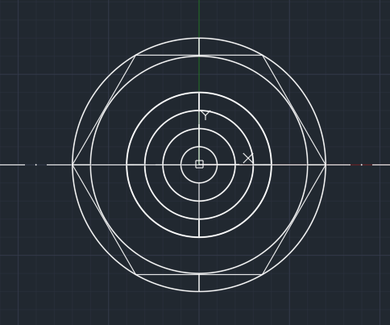

Command: INTERSECT

Select objects: 1 found

Select objects: 1 found, 2 total

Select objects:

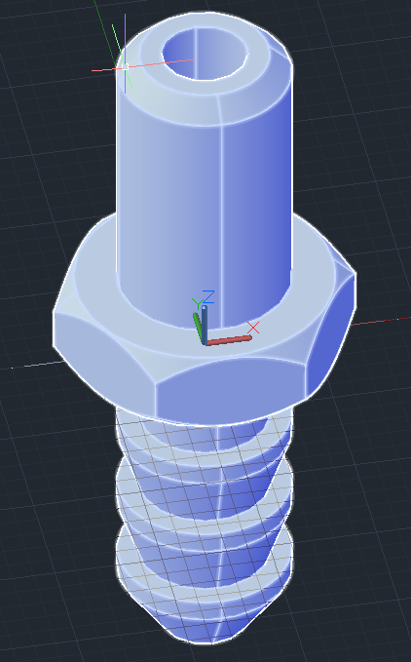

Деталь 2

Command: RECTANG

Specify first corner point or [Chamfer/Elevation/Fillet/Thickness/Width]: F

Specify fillet radius for rectangles <0.0000>: 20

Specify first corner point or [Chamfer/Elevation/Fillet/Thickness/Width]: 100,100

Specify other corner point or [Area/Dimensions/Rotation]: 500,300

Command: CIRCLE

Specify center point for circle or [3P/2P/Ttr (tan tan radius)]: 140,260

Specify radius of circle or [Diameter]: 10

Command: CIRCLE

Specify center point for circle or [3P/2P/Ttr (tan tan radius)]: .X

of CEN

of (need YZ): .Y

of 111111,140,55555

(need Z): 12312,12341,0

Specify radius of circle or [Diameter] <10.0000>:

Command: CIRCLE

Specify center point for circle or [3P/2P/Ttr (tan tan radius)]: 460,140

Specify radius of circle or [Diameter] <10.0000>:

Command: CIRCLE

Specify center point for circle or [3P/2P/Ttr (tan tan radius)]: .X

of CEN

of (need YZ): CEN

of

Specify radius of circle or [Diameter] <10.0000>:

Command: REGION

Crossing Lasso Press Spacebar to cycle options5 found

Select objects:

5 loops extracted.

5 Regions created.

Command: SUBTRACT

Select solids, surfaces, and regions to subtract from ..

Select objects: 1 found

Select objects:

Select solids, surfaces, and regions to subtract ..

Crossing Lasso Press Spacebar to cycle options4 found

Select objects:

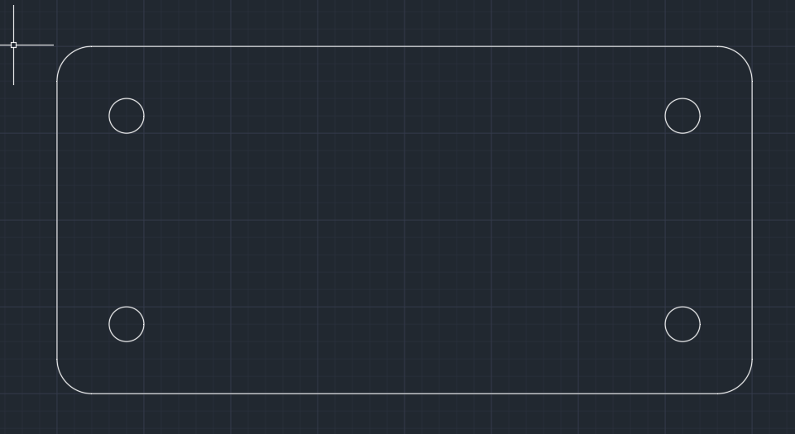

Command: EXTRUDE

Current wire frame density: ISOLINES=4, Closed profiles creation mode = Solid

Select objects to extrude or [MOde]: 1 found

Select objects to extrude or [MOde]:

Specify height of extrusion or [Direction/Path/Taper angle/Expression]: 30

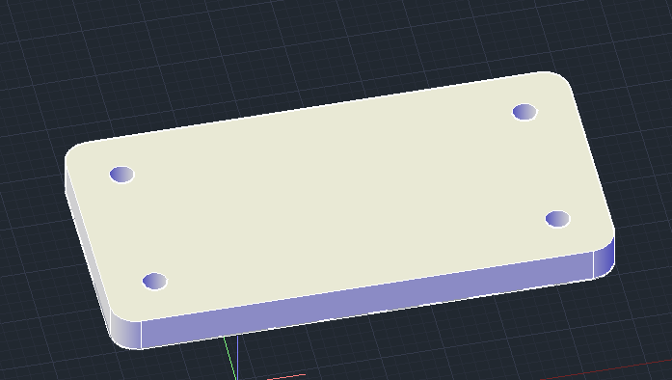

Command: CONE

Specify center point of base or [3P/2P/Ttr/Elliptical]: CEN

of

Specify base radius or [Diameter] <15.0000>: 15

Specify height or [2Point/Axis endpoint/Top radius] <-15.0000>: -15

Command: COPY

Select objects: 1 found

Select objects:

Current settings: Copy mode = Multiple

Specify base point or [Displacement/mOde] <Displacement>: CEN

of

Specify second point or [Array] <use first point as displacement>: CEN

of

Specify second point or [Array/Exit/Undo] <Exit>: CEN

of

Specify second point or [Array/Exit/Undo] <Exit>: CEN

of

Specify second point or [Array/Exit/Undo] <Exit>:

Command: SUBTRACT

Select solids, surfaces, and regions to subtract from ..

Select objects: 1 found

Select objects:

Select solids, surfaces, and regions to subtract ..

Select objects: 1 found

Select objects: 1 found, 2 total

Select objects: 1 found, 3 total

Select objects: 1 found, 4 total

Select objects:

